|  |
| --- |
| South Africa Livelihood Zone Profile  59301 – North Eastern Limpopo Open Access Farming (*ZALOF*) |
| Zone Description |

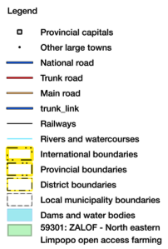This zone lies entirely in Vhembe district on the southern slopes the Soutpansberg range. Livelihoods are based on farming and other sources of income such as casual labour, small business, grants and salaried employment.

Figure 1: Map of the livelihood zone

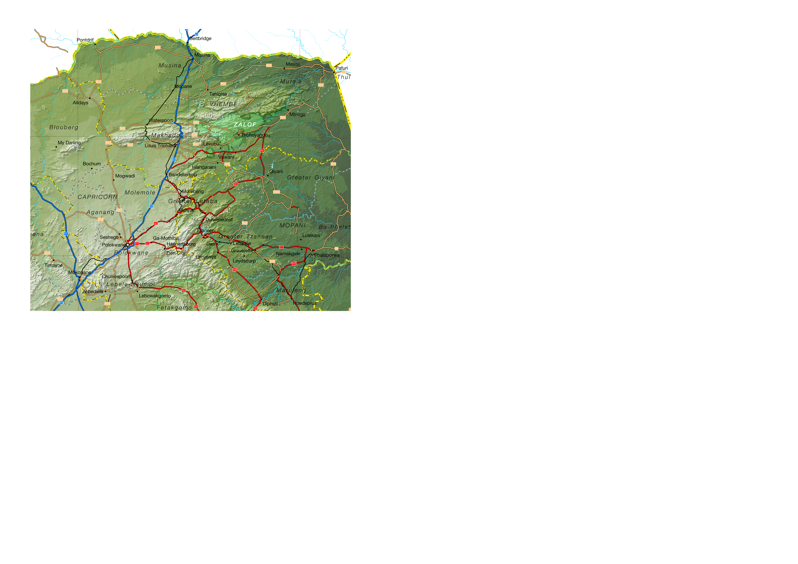Projection: Albers Equal Area with Standard Parallels at 22.67 S and 24.88 S, Longitude of Centre at 29.29 E.

Sources of data: Open Street Map, Highways (<http://wiki.openstreetmap.org/wiki/Planet.osm>) for the road lines, Shuttle Radar Topography Mission (SRTM) 3 version 2.1 (<http://www2.jpl.nasa.gov/srtm/>) for the elevation and relief shading and Agricultural Geo-referenced Information System (AGIS) (<http://www.agis.agric.za/agisweb/agis.html>) for place names, boundaries and rivers.

The zone is well-watered, with an average annual rainfall of 600 mm to 1,000 mm. Being tropical and in the mountains, it enjoys a moderate climate that makes it a productive farming area, with tropical fruits and vegetables. It is densely populated and farm holdings are small. Slope decreases the land available for cultivation.

Table I - Census 2011 population breakdown of districts and municipalities covered by the livelihood zone

|  |  |  |  |  |
| --- | --- | --- | --- | --- |
| **Province** | **District** | **Municipality** | **Pop. Est. in ZALOF** | **Percent of total** |
| Limpopo | Vhembe | Makhado | 111,234 | 21.69% |
| Mutale | 6,246 | 6.81% |
| Thulamela | 273,666 | 44.26% |
| **Provincial Total** |  |  | **391,146** | **7.24%** |

Source: Statistics South Africa, Census 2011 Small Areas.

Figure 2: Livelihood zone location



**Figure 1** is a map of the zone and **Figure 2** shows the location. The R524 and the R529 are important feeder roads through the zone, connecting it to the main north-south N1 highway. The main centre for administration and commerce is Thohoyandou, with Louis Trichardt and further away, Polokwane, acting as additional centres. Thohoyandou itself has many satellite towns and centres that serve as centres for trade and as transport hubs.

The livelihood zone has been given an alphabetic code (or abbreviation) of 'ZALOF' and a numeric code of 59301. These codes distinguish the zone both nationally and internationally, as well as allowing zone name changes and updates if desired (the code should always remain the same).

The zone spans three municipalities in one district. However, not all of each of these three municipalities are included in the zone; substantial areas and populations from each municipality are excluded. The total population in the zone is 391,146 (from the Census 2011) and this is 7.24% of the provincial total. **Table I** shows the breakdown for each municipality.

Figure 3: Gender and age breakdown of the zone population

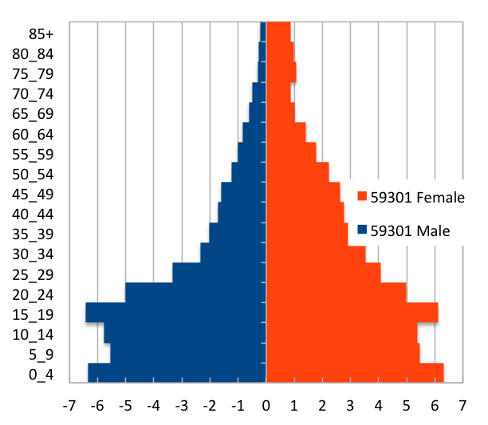 Source: Statistics South Africa, Census 2011 small areas and population database

The age and gender breakdown of the livelihood zone is given in **Figure 3**. It is important to note the low proportions of adult men in the livelihood zone as well as the high proportion of children (younger than 20). This unbalanced gender and dependency ratio is a consequence of apartheid, as the zone was a part of a former *bantustan* (Venda), supplying labour to urban, industrial and mining areas. The persistence of this pattern leads to shortages in the zone of human capital, which has impacts on productivity.

|  |
| --- |
| Seasonal Calendar |

Since this is a rural livelihood zone and rural life is determined by agricultural seasons, the information is organised by *consumption year*, which begins with the start of the main dry harvest and runs through to just before the next year's main dry harvest. In this zone, the main dry harvest begins in March, so the consumption year begins that month and runs up until the end of the following February. The livelihood strategies presented in this document apply to a particular year, one that is neither very good nor bad but is 'typical', or occurs frequently. This is called the *reference year* and the year chosen by participants was 2013-2014, or March 2013 to February 2014.

Farming has two main seasons: cereals (maize) and vegetables. The land for maize cropping is prepared in late winter and spring, with ploughing and planting taking place from September to January, depending on the timing of the rains. Weeding (a period of intense activity and one in which work opportunities increase) takes place from November to February, with the dry harvest (another period for employment) beginning in March.

Figure 4: Seasonal calendar

|  |  |  |  |  |  |  |  |  |  |  |  |  |
| --- | --- | --- | --- | --- | --- | --- | --- | --- | --- | --- | --- | --- |
| **Activity** | Mar | Apr | May | Jun | Jul | Aug | Sep | Oct | Nov | Dec | Jan | Feb |
| Dry harvest & threshing |  |  |  |  |  |  |  |  |  |  |  |  |
| Land preparation (maize) |  |  |  |  |  |  |  |  |  |  |  |  |
| Land preparation(Vegetables) |  |  |  |  |  |  |  |  |  |  |  |  |
| Ploughing & planting (maize) |  |  |  |  |  |  |  |  |  |  |  |  |
| Ploughing & planting (Vegetables) |  |  |  |  |  |  |  |  |  |  |  |  |
| Weeding (maize) |  |  |  |  |  |  |  |  |  |  |  |  |
| Weeding (Vegetables) |  |  |  |  |  |  |  |  |  |  |  |  |
| Harvesting (vegetables) |  |  |  |  |  |  |  |  |  |  |  |  |
| Casual Labour (domestic work, crop fields, herding & public works) |  |  |  |  |  |  |  |  |  |  |  |  |
| Off-Farm Employment |  |  |  |  |  |  |  |  |  |  |  |  |
| Livestock sales |  |  |  |  |  |  |  |  |  |  |  |  |
| Purchases |  |  |  |  |  |  |  |  |  |  |  |  |

Vegetable farming is stretched out longer and vegetables are planted more continuously, to bring a steady income. Land preparation takes place through autumn, winter and spring up to September, with planting happening at the same time. They are tended and weeded through the same seasons up until October, by which time harvesting is completed.

The peak period for casual work availability is from November to February, while off-farm work is also available during winter from May to August. Livestock sales tend to peak in winter from May to Jul and in spring or early summer, from October to January. The latter is often to pay for summer expenses such as the Christmas holiday season.

|  |
| --- |
| Wealth Breakdown |

Wealth in this livelihood zone is determined by four factors:

1. Employment, a product education and good social connections;
2. Ownership of a business, such as a spaza shop or bakkie, taxi;
3. Land holding; and
4. 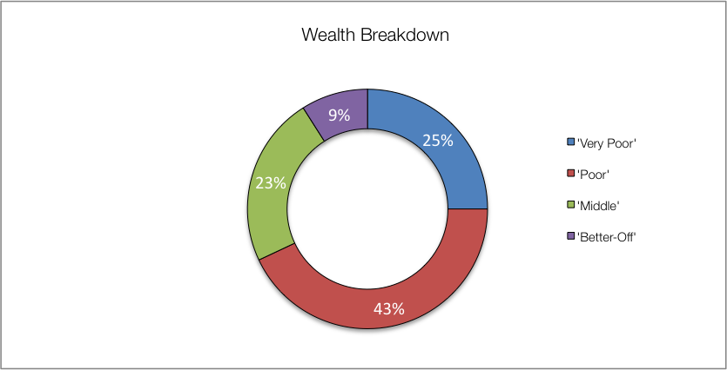Livestock, especially cattle.

Figure 5: Wealth breakdown in the north eastern Limpopo open access farming livelihood zone

|  |  |  |  |  |  |
| --- | --- | --- | --- | --- | --- |
| Category | Item | Wealth Group (typical value in brackets) | | | |
| 'Very poor' | 'Poor' | 'Middle' | 'Better off' |
| Hh Size |  | 4-10 (6) | 4-9 (6) | 4-7 (5) | 4-6 (5) |
| Land (Ha) | Owned | 0-1 (¼) | ¼-1 (0.7) | 1-3 (1½) | 2-5 (3) |
| Cultivated | 0-1 (0.2) | ¼-1 (½) | 1-3 (1.3) | 2-5 (3) |
| Livestock (head) | Cattle | 0 | 0-6 (3) | 6-15 (9) | 10-50 (12) |
| Goats | 0-3 (0) | 0-4 (3) | 5-10 (7) | 0-20 (10) |
| Income | Main | Grants | Grants | Formal employ | Formal employ |
| Annual (R) | 27,200 | 56,100 | 175,600 | 272,200 |

Source: Survey output, 2015

The wealthiest households, described as the 'better-off', are those with permanent work and a salary of R12,000 per month or more. Households that have lower-paying or less permanent work, which when averaged over the year is approximately R10,000 per month, are referred to as the 'middle'. Those who depend primarily on grants are described as the 'poor' and 'very poor'; collectively, they are almost four-fifths of households. The 'very poor' and 'poor' supplement their grant income from casual labour and other sources.

Land in this zone is good for farming and the population density is high, resulting in pressure on what is a finite resource. Households with more wealth are thus able to secure more land and cultivate farms that are up to fifteen times larger than those of the poorest households.

Livestock holdings also increase substantially with wealth. Cattle are considered more as determinants of wealth; wealthier households do keep them, while they may not keep any small stock—although on average, they do keep more goats than poorer households.

Key informants in the villages tended to estimate larger household sizes, so field teams recorded values in excess to those reported in other surveys, especially the census. Except for single-people, the greatest number of people reside in a household of four people, which is also the most frequently occurring household size. This is less than the reported household size of five to six, which is used in ensuing sources of food and income—these can be scaled to the appropriate household size from the census.

|  |
| --- |
| Sources of Food |

Despite the good rainfall and fertile soils, purchases still make up the largest portion of people's sources of food. Food purchases contribute 60% to 80% of food energy needs; this is lower than in other livelihood zones in the province (which are 80% to 100%) but is still more than half of requirements. The contribution to food energy from staple food purchase *decreases* steadily from 75% for the 'very poor' to 29% for the 'better off'. Conversely, the contribution to food energy of non-staple food purchases *increases* with increasing wealth, from 4% for the 'very poor', to 48% for the 'better off'.

The contribution to food energy needs from own crop production increases with increasing wealth, from 17% for the 'very poor' to 57% for the better off. The breakdown into staple and non-staple does not follow any pattern with wealth; the contribution from non-staple crops being about 4% to 8%. Yields in the zone are low, given the fertility and land capability—'very poor' and 'poor' households obtain only 800 kg/Ha, this rises to 1,200 kg/Ha for the 'middle' and 1,800 kg/Ha for the 'better off'. Wealthier households have capital for inputs and hired labour, ensuring their crops are planted and weeded in time as well as being protected from pests.

Figure 6: Sources of food (expressed as percentage of minimum average food energy needs) for each wealth group

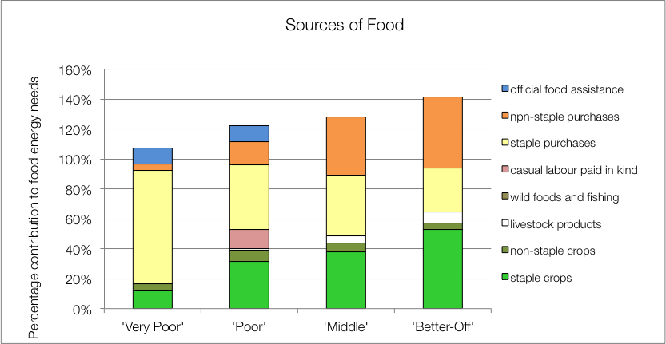

'Middle' and 'better off' households obtain a tiny proportion of their needs from their livestock; this is usually from cow's milk and occasional slaughter for meat. Dairy production in this zone is not commensurate with herd sizes and livestock ownership. In general, a fraction of lactating cows (about 1 in 8) are milked for consumption.

The poorest households' children receive additional food from school lunches, which is their official food assistance. Wealthier households tend to send their children to fee-paying schools that do not offer meals.

|  |
| --- |
| Sources of Cash Income |

Cash incomes vary considerably across wealth groups, with the 'better off' earning R272,200 per annum, ten times as much as the 'very poor', who earn only R27,200 per annum. **Figure 7** shows this distribution—it must be noted that the bars in the figure are not quartiles, they represent wealth groups and wealth groups are *not* distributed evenly (see **Wealth Breakdown**, above).

Figure 7: Sources of annual cash income by wealth group

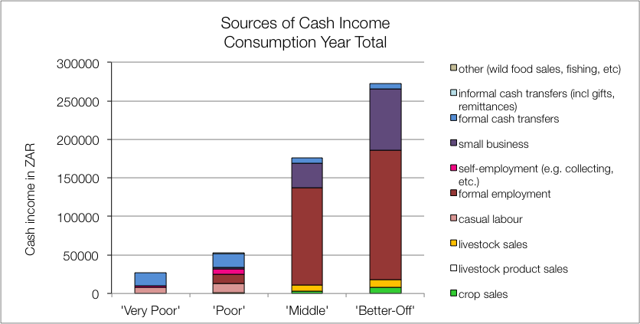

The main sources of cash incomes in the zone are: formal employment—for the 'middle' and 'better off'—and cash grants—for the 'poor' and 'very poor'. This is in keeping with most surveys that ask for the main livelihood source.

However, the point of this enquiry was to gain understanding of how *all* livelihood sources come together to make up an income. This is essential because it enables practitioners to link a hazard (such as a price change) to outcomes and it enables other users to see potential areas of intervention. By dividing the value of each source by the total income, we can see these proportions and this is presented in the graph in **Figure 8**.

For the 'very poor' and 'poor', grants make up 64% and 32% of total cash income, respectively; the remainder coming from casual labour (mostly domestic work, agricultural piece work, construction jobs) and self-employment (collecting natural products for sale, weaving, making bricks, etc.). The 'poor' earn small amounts of income through livestock sales—usually goats (7%), petty trading (3%) and remittances (3%). This, coupled with a small income from the formal sector (R12,000 annually or 21%) is what distinguishes their livelihoods from that of the 'very poor'.

Figure 8: Sources of annual cash income as a percentage of total, by wealth group

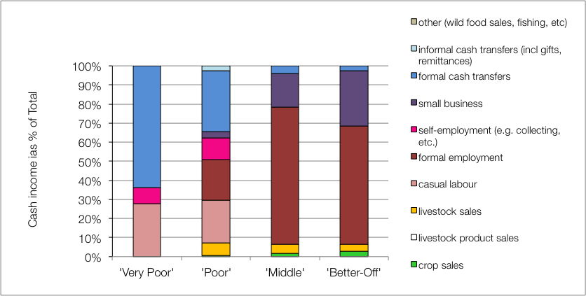

The 'middle' and 'better off' gain their cash from a formal wage or salary for the better part of their income. Some 'middle' households may have a member that works seasonally on the commercial farms but earnings typically amount to almost R126,000 per annum, while the 'better off' earn around R168,000 per annum. 'Middle' and 'better off' households also gain a little cash from grants (for example, pensions and fostering are not means-tested and the probability of a household having a pensioner in it is about one in two—see the population pyramid under **Zone Description**).

It can be seen that the earnings from livestock products are nil, which is lost productivity. The numbers of cows that are actually milked compared with those likely to be lactating is low and this is due to a number of factors: lack of economic incentives for milking, lack of time by the cattle-owners (because they are full-time employed) and minimal herd management.

|  |
| --- |
| Hazards, Vulnerabilities and Response Strategies |

Since households are dependent on markets for most of their food, they are therefore most vulnerable to market shocks. These 'market shocks' may consist of: escalating food prices, eroded grants (for example, when they are not adjusted to match consumer inflation) and job losses.

Drought may have an impact, reducing crop production and removing this source of food. However, unless food prices also rise simultaneously, households will manage crop losses by prioritising more cash to their food purchases.

Additional response strategies households may engage in under stress are: switching expenditure, seeking more casual work (usually outside of the village) or selling off assets or belongings.

|  |
| --- |
| Household Hunger Score |

The majority of the households (83%) experience no to little hunger and no household had severe hunger in this livelihood zone. Only 17 per cent of the households reported a moderate hunger situation (see **Table II**)

Table II - Household Hunger scale indicator

|  |  |  |  |  |  |
| --- | --- | --- | --- | --- | --- |
| No to Little Hunger | | Moderate Hunger | | Severe Hunger | |
| Count | Percent | Count | Percent | Count | Percent |
| 69 | 83 | 14 | 17 | 0 | 0 |

Source: Survey Output 2015

|  |
| --- |
| Dietary Diversity and Food Consumption Score |

The largest number – 37 percent – of the sampled households have the highest dietary diversity score indicating that they consume at least six food groups in the previous day of the survey. 31 Percent of households have medium dietary diversity (about four to five food groups) and 31 percent of households also reported having the lowest dietary diversity indicating that they consume three or less food groups.

By the food consumption score, the majority of households (72%) were consuming poor diets. While 16 per cent of the households were within acceptable consumption pattern, about 12 per cent of the households were within borderline consumption pattern.

Figure 10: Food consumption scores

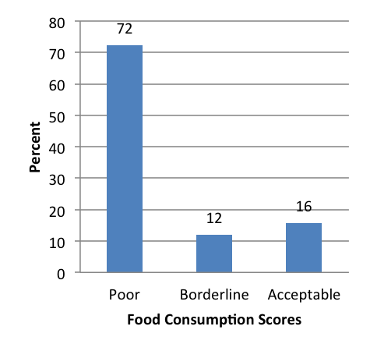

Figure 9: Dietary Diversity Scores

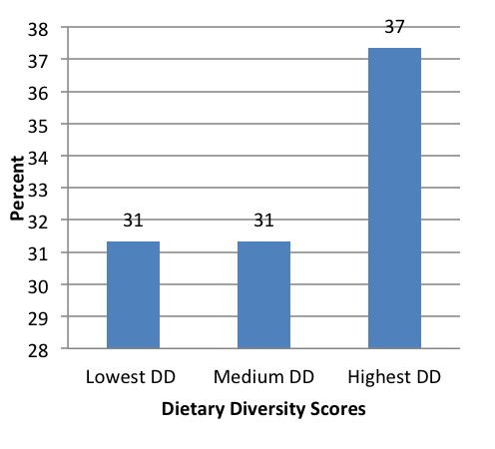

|  |
| --- |
| Nutrition and Anthropometry |

Acute malnutrition is predominant in the 36-47 months old children in the livelihood zone (Figure 11). About 14 percent of under-five children were moderately and severely malnourished. The results also indicate that there were no children under-five of age who were severely or moderately malnourished within zero months to 35 months of age in the livelihood zone.

Figure 11: Prevalence of severe and moderate acute malnutrition by age grouping

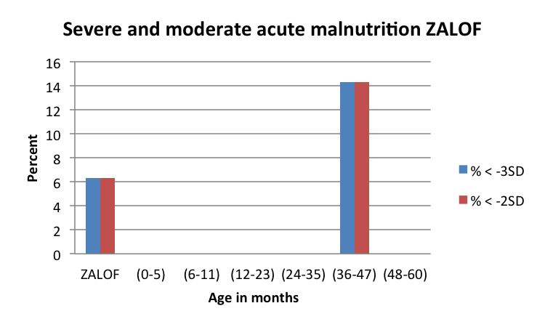

The prevalence of severe and moderate stunting is 31 per cent and 39 per cent, respectively in the livelihood zone (Figure 12). There is a high prevalence of severe and moderate stunting among under-five children within 24 to 35 months of age seconded by children who are 48 to 60 months old. The results also indicate that there were no under-five children who were either severely or moderately stunted within age categories of zero to eleven months and between 36 and 47 months within the livelihood zone.

The prevalence of severe and moderate underweight is at 13 per cent in the livelihood zone (Figure 13). About 33 per cent of under-five children who are severely and moderately underweight are within 24 to 35 months of age whereas 17 percent of the under-five children are within 36 to 47 months old. The rest of the age groups have no severely or moderately underweight under-five children in the livelihood zone.

Figure 12: Prevalence of severe and moderate stunting by age grouping

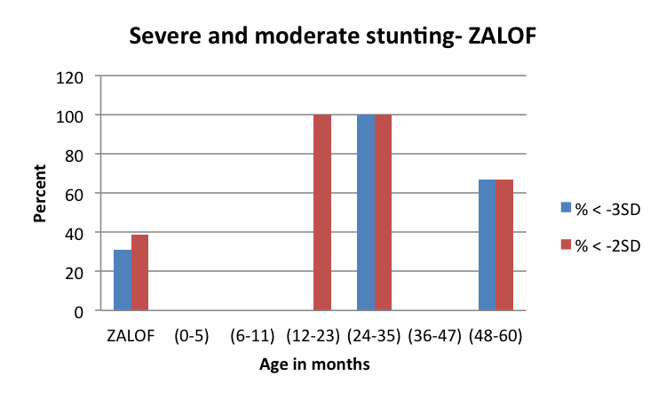

Figure 13: Prevalence of severe and moderate underweight by age grouping

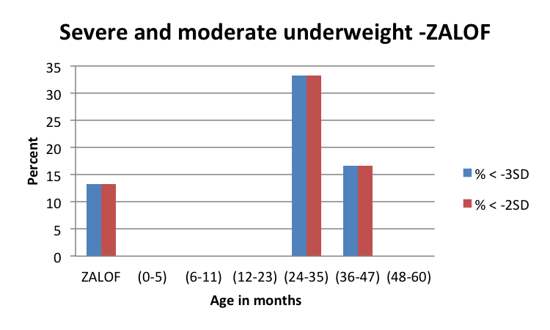

|  |
| --- |
| Conclusions and Recommendations |

As already mentioned, food and cash income from livestock products is low for the numbers of animals present. To increase production, herds would need more and better management, an investment for the owner that would need to be justified with better returns. These returns could be increased by, for example, support to dairy marketing and greater provision of services and infrastructure to encourage production. Increasing livestock will most likely only benefit the wealthiest ('middle' and 'better off') households directly, but it will create additional new possibilities for poorer households through increased work opportunities.

Crop farming yields are another area where improvements can be made to people's livelihoods. This can be attained by greater service provision and market support. This will not only strengthen incomes and provide alternative food sources, it will increased opportunities for work within the communities.

Crop production data is difficult to obtain in open-access (traditional tenure) farming areas. The first step to improving livelihoods should be in measuring output from existing systems, therefore simple crop surveys are essential. Crop surveys will also enhance the efficacy of outcome analysis and forecasting, based on the information in this profile.